Do you want to hack your friends Facebook account ?
Yes !
Read out simple steps, How you can hack your friends Facebook account easily.
Facebook is the biggest and most popular social networking website today. However along with the growing popularity of Facebook, it is also gaining a wide attention of hackers as well. There are many ways to hack a Facebook account. Some of them include – Keylogging, Phishing and Scripts etc. However these are the general methods that are used by professional hackers. But in this post I am going to outline a very easy way to hack the Facebook account of a friend of yours without having any hacking expertise.
This method basically helps you in hacking the password of your friend’s account using Facebook’s security system. But firstly you need to make sure of creating at-least three fake accounts and get them added in your friend’s account that you want to get hacked. Make sure you have access to all these 3 fake accounts.

Step by Step Guide to hack Facebook account of a friend :
- Open Facebook.com and Click on “Forgot Facebook Password” button. You will be presented with three options to recover the password of the Facebook account.
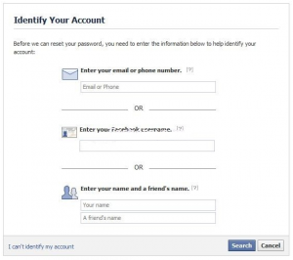
- Choose any one of these options. First option needs you to fill email address of your friend whose account you want to hack. Otherwise you can choose second option by filling the username for your friend in it. Also there is third option available where you need to enter the name of the victim friend and your own name.
- Next you have to click on the Search button.
- If all above steps are followed properly then you will be able to see the profile picture of your victim friend. Confirm this step by hitting “This Is My Account”
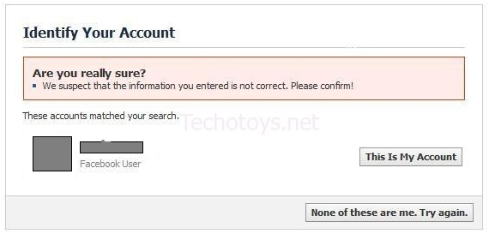
- Now the interface will show you option to recover password using the email id of your friend. You have to click on “No Longer Have Access to These” link.
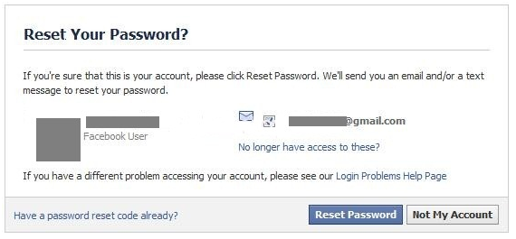
- Next enter a totally new email id in the form provided. Make sure that the email address should not be associated with some other Facebook account. Hit the Submit button.
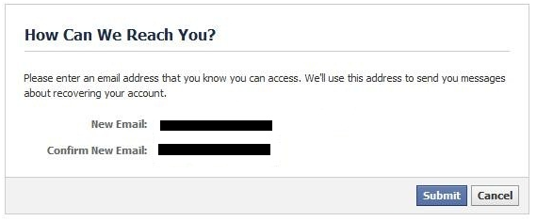
- Now you will be provided with the option to answer the security question set up by your friend or actual owner of that Facebook Account. If you can guess the right answers to the security question then it’s a big advantage otherwise you need to enter the wrong answer for three times. After entering wrong answer for three times you will be taken to the following page:
- Here you need to choose the name of three friends that are on your Facebook friends list. These should be those 3 fake accounts that you have created in the very beginning. Now click on Continue button to advance to the next step.
- Facebook system will send security codes to all of those three accounts chosen in previous step. Now login to each of those 3 fake accounts and get the security codes from there and get them filled in the form offered by the Facebook.
- The last action taken by Facebook will be to direct a Password reset email to the new email address entered by you above from where you can reset the password and will gain complete access to your friend’s Facebook account.
Dont Miss : How to increase Facebook fans on your pages.
This is all! Just few simple steps and some smart work to do and then you will be having complete control over your friend’s Facebook account and profile. If you have any other method to hack then let us know. Thank you

